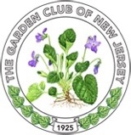

President’s Project Award Application
“Plant Trees: Nature’s Unsung Heroes”

Grant Application due to GCNJ Awards Chairman by February 15, 2022
Limit to three pages

Name of Club: District:
Date Submitted: Number of club members:

Club President:
Address:
Phone: Email:

Club Awards Chair:
Address:
Phone: Email:

New Project: Y____ N_____ Beginning Date: ____________ Completion Date:____________

Project title:

Proposed expenses and source of funding:

Involvement of club members, other organizations:

Continuing involvement, follow-up, maintenance:

Project Description:

Attach photos, landscape plan or other pertinent documentation

One sided, no covers, mail three copies to GCNJ Awards Chair Peggy Morrisey by due date.
142 Osborne Ave., Bay Head, NJ 08742-4624

