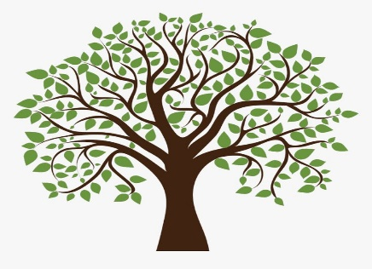

Plant Trees: “Nature’s Unsung Heroes”
President’s Project Grant for 2022 & 2023

- Three $1000 grants will be awarded to local NJ Garden Clubs for a project that focuses on the planting of native trees.
- An example of the format for this grant will be posted on line, in the Awards section of GCNJ website
- Applications are due by February 15, 2022
- Applications will be reviewed and awarded by President’s Project Chair-Teddie Falcone, Awards Chair-Peggy Morrisey and President-Cecelia Millea
- Awards will be announced at the GCNJ Annual Meeting in June of 2022 and 2023
- Planting native species of trees helps to re-establish the original eco-system of the region

