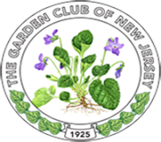
President’s Project Grant
Plant Trees: “Nature’s Unsung Heroes”
Grant Application due to Awards Chair – February 15, 2022
Limit to three pages using format below
Name of Club:
District:
Club President: address:
Phone: email:
Club Award Chair: address:
Phone: email:

Project Description (include start date, completion date and project title as well as a brief description of project and plans for ongoing maintenance)

Objectives of project and proposed budget:

Involvement of club members, other organizations:

Attach photos, landscape plan or other pertinent documentation:

One sided, no covers, mail three copies to GCNJ Awards Chair Peggy Morrisey by due date.
142 Osborne Ave., Bay Head, NJ 08742-4624

