Fun Information to assist with Grant submissions for Plant Trees: “Nature’s Unsung Heroes”
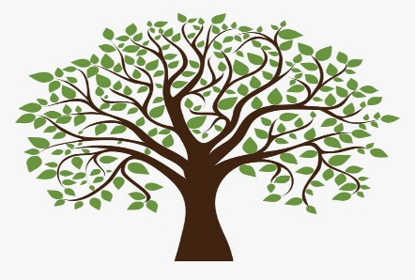
- Native Plant Society of New Jersey has Native Tree Recommendations by Hubert Ling on their website: NPSNJ.org

- Why native trees? Plant Trees and Invest in the Future:

- Trees developed in this region, are better suited to grow here than an alien species.

- Once established they require less water and fertilizer than non-native species.

- Trees absorb airborne pollutants and trap airborne dust particles.

- One large tree can produce enough oxygen to support up to 4 people.

- Trees reduce erosion by holding water in their systems and then releasing it into the air.

- Trees cool the air and provide food and shelter for many species.

- Trees provide enjoyment and add beauty to our community.

- This is an opportunity to educate, unite the community and contribute to environmental awareness!

